# Using Dreamweaver Templates for Website Building

When creating your Rutgers-themed website using the provided Dreamweaver templates, please use the following instructions.

## Create a Website In Dreamweaver

The first thing you will want to do to build your website is to utilize Dreamweaver’s site management abilities. By creating a “new site” within Dreamweaver, it will be easier to organize your content and upload the pages to your web server.

1. At the top of the Dreamweaver program, click the  icon. This will open the option to create a new site.  
     
   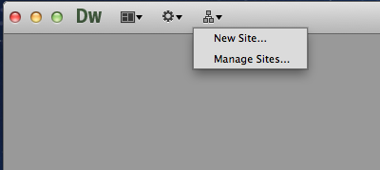
2. Click on “New Site…”
3. Enter a name for your site.
4. Choose where you want the site to be saved on your computer. (We will later on choose how it gets up on to the server to be viewable by the world.)  
     
   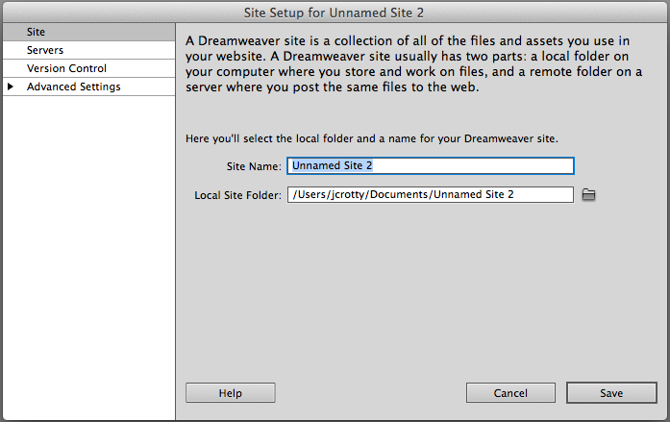
5. Click on “Servers” in the lefthand menu.
6. Click on the  button to add the server where you will upload your webpages for the public to view.  
     
   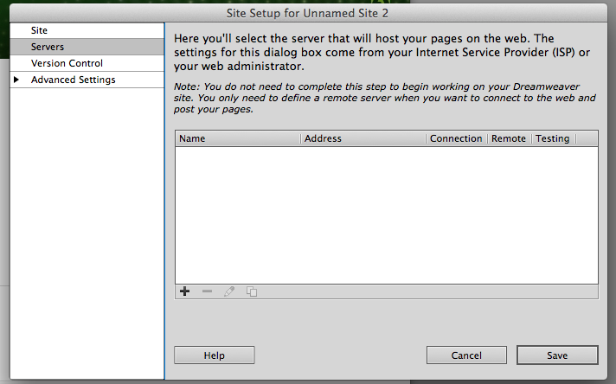
7. Add a name for the server for your own reference. Then choose the connection type and the login credentials. If you are unsure of this information, contact an IT person to assist you.  
     
   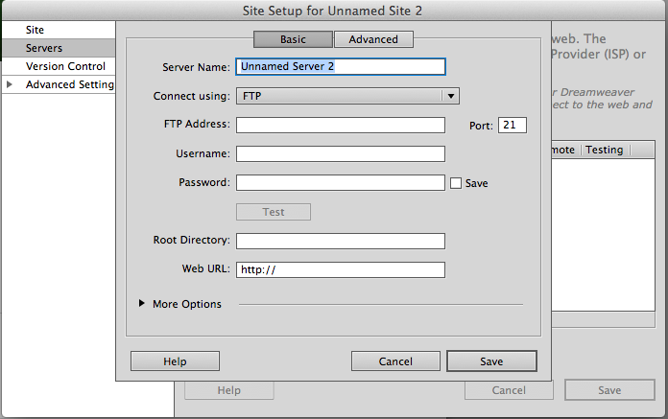
8. Once all information is in, click the Save button in the current window, and then click the Save button in the Site Setup window.

## Create the Homepage with a Template

Follow the instructions for creating a homepage from a predefined template.

1. On the top of the Dreamweaver program, click on “File” and select “New…”

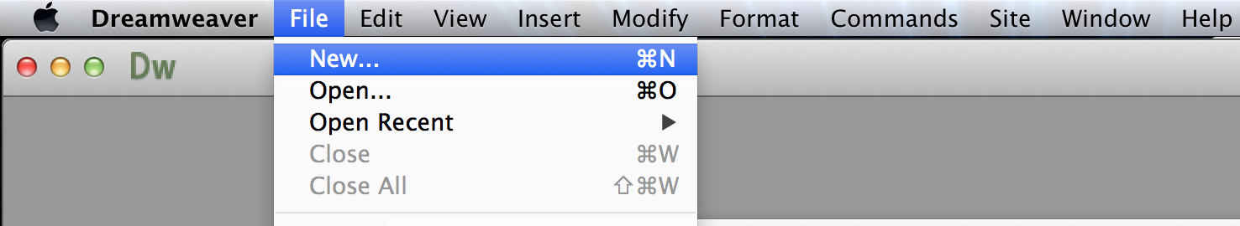

1. On the new popup screen, select “Site Templates” on the left navigation.

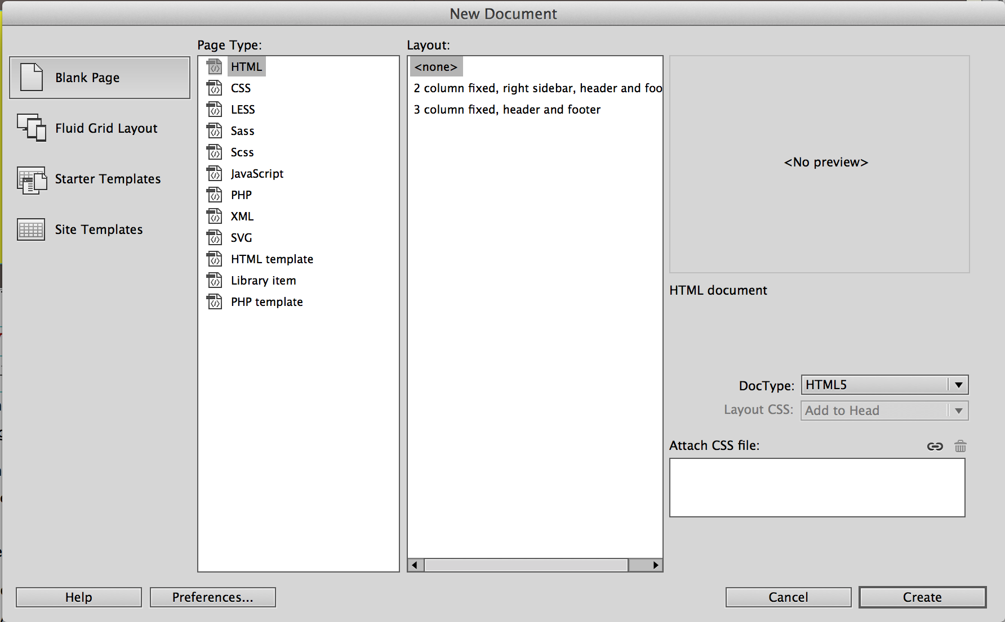

1. From the first white panel (under Site), select “Master Rutgers Template”.

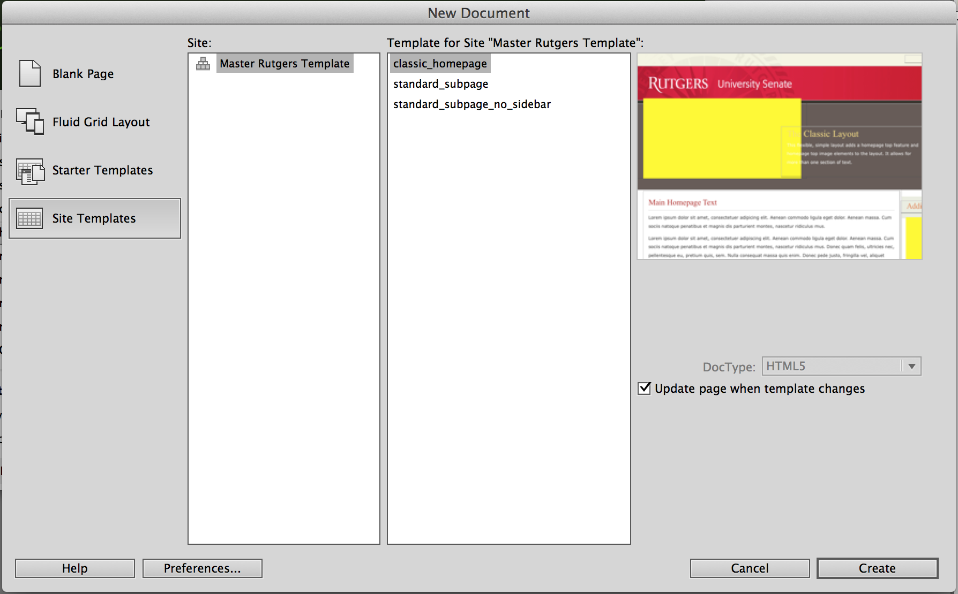

1. From the second white panel (under Template for Site “Master Rutgers Template”), select “classic_homepage”.



1. Click “Create” or hit enter to generate the homepage using the selected template.
2. Be sure to save the homepage as index.shtml. To save, click on “File” then select “Save”.

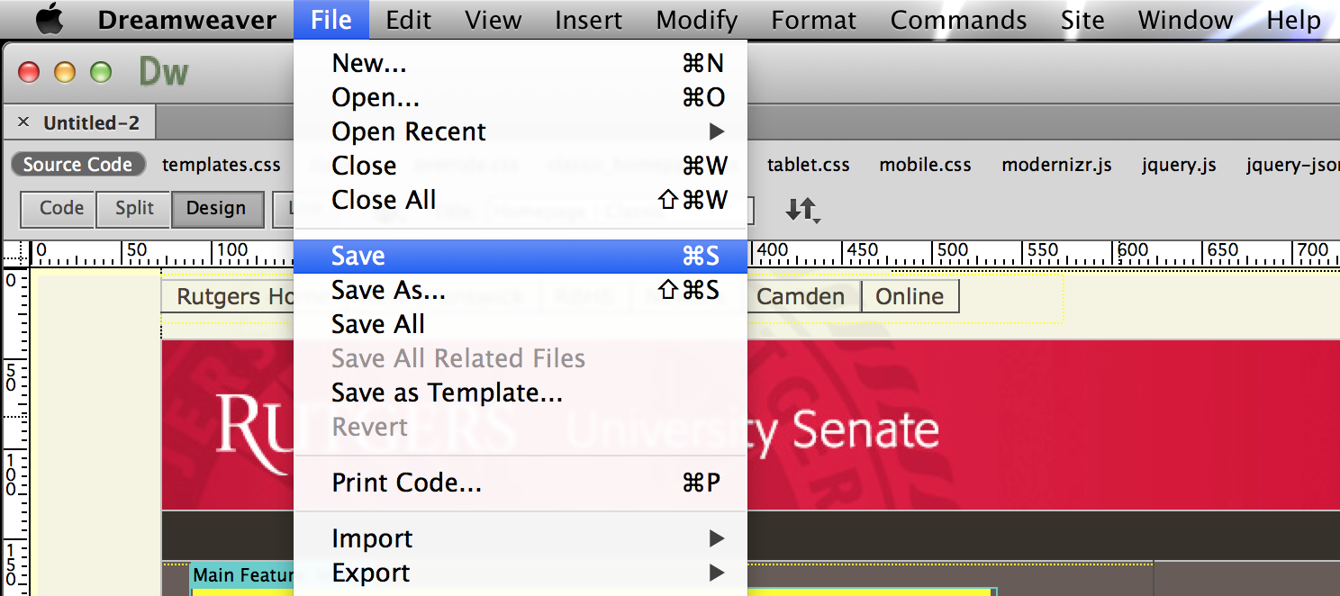

1. Next to “Save As”, please enter the following: **index.shtml**

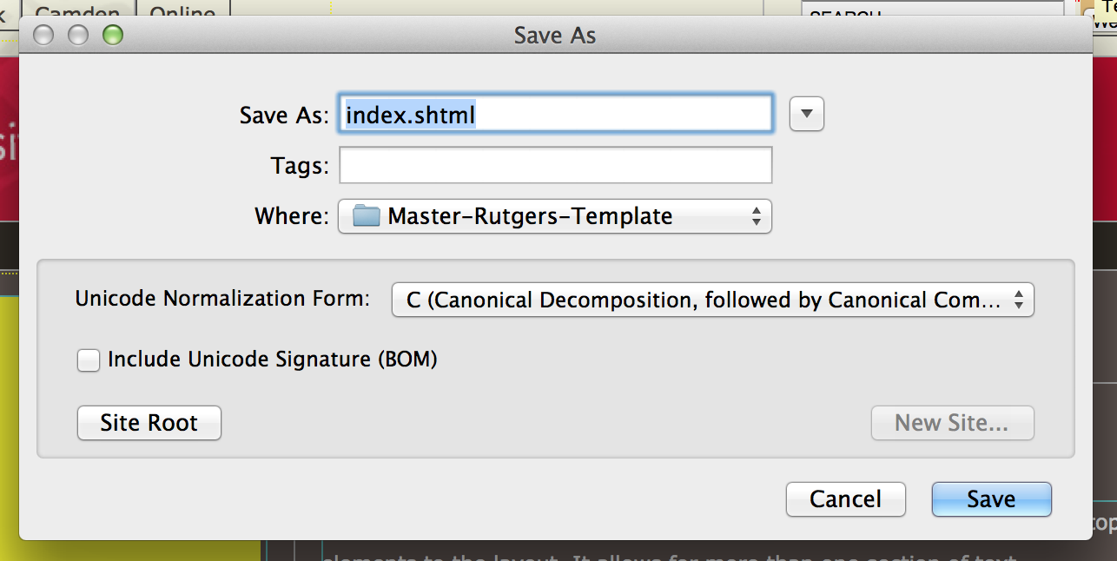

### Content Areas of Your Homepage

The homepage contains four distinct content areas:

1. Homepage main feature image
2. Homepage main feature text
3. Site map
4. Sidebars

#### Main Feature Image

The image placed here is normally 443px wide and 225px tall. These numbers are not set in stone, however you are more guaranteed that the image will work with the design of the page if you stick to those dimensions.

#### Main Feature Text

This text can contain a header and body text. It is advisable to keep the text here short enough so that it does not go longer than the feature image on the lefthand side.

#### Site Map

This text area beneath the main feature area is intended for placing a text site map of the website. However, any sort of text can be added here.  
  
To create links out of the text you type in here, highlight the text to become a link, then in the Properties panel, add the filename of the webpage you are linking to (such as about.shtml).  
  
The option to create bulleted lists is also available in the Properties panel. Also available are options such as bold, italics, and indent.  
  
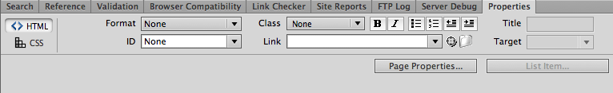

#### Sidebars

Beneath the main feature area and to the right of the site map area is a column of space available for adding sidebars. In the template provided to you, there is one already available. However, you may add more if you desire.

* To create new panels, please select the “+” button that is hovering on top of the title of the panel.

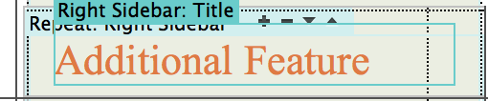

* The images on each panel are optional. To delete, simply select the image and hit the delete button on the keyboard.

## Create a New Page with a Template

Follow the instructions for creating a subpage from a predefined template.

1. On the top of the Dreamweaver program, click on “File” and select “New…”



1. On the new popup screen, select “Site Templates” on the left navigation.



1. From the first white panel (under Site), select “Master Rutgers Template”.



1. From the second white panel (under Template for Site “Master Rutgers Template”), select one of the following options:
   1. For subpages with a right sidebar, select “standard_subpage”
   2. For subpages without a right sidebar, select “standard_subpage_no_sidebar”

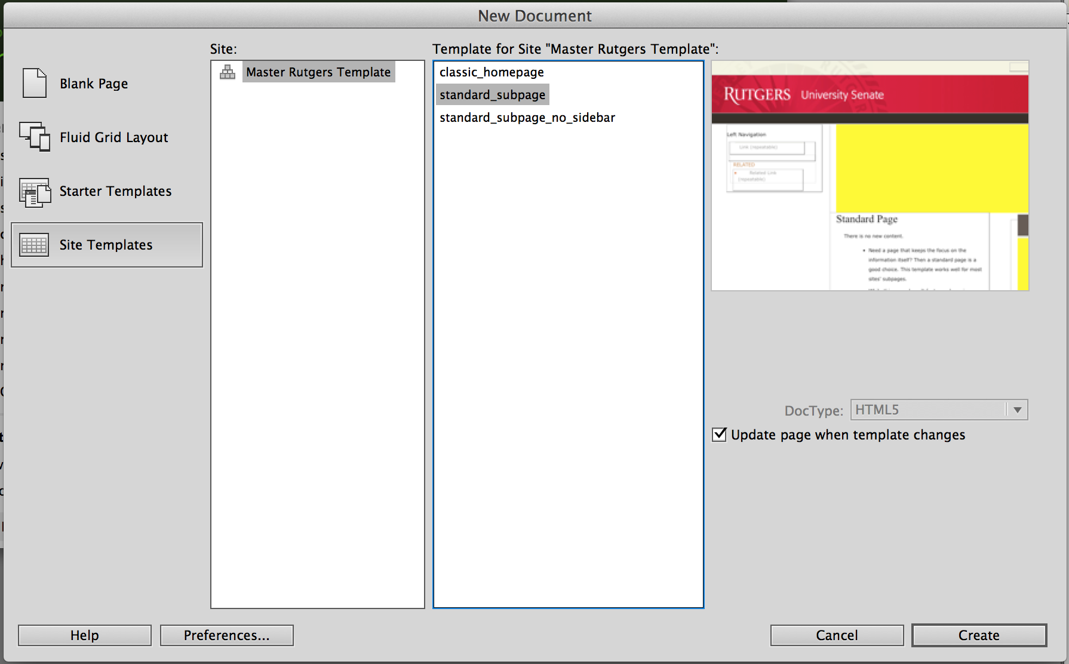

1. Click “Create” or hit enter to generate the homepage using the selected template.
2. Be sure to save the subpage as .shtml file. To save, click on “File” then select “Save”.



1. Next to “Save As”, please enter the following the appropriate filename with **.shtml** extension. I.E. For the About Us page, save the file as about.shtml.

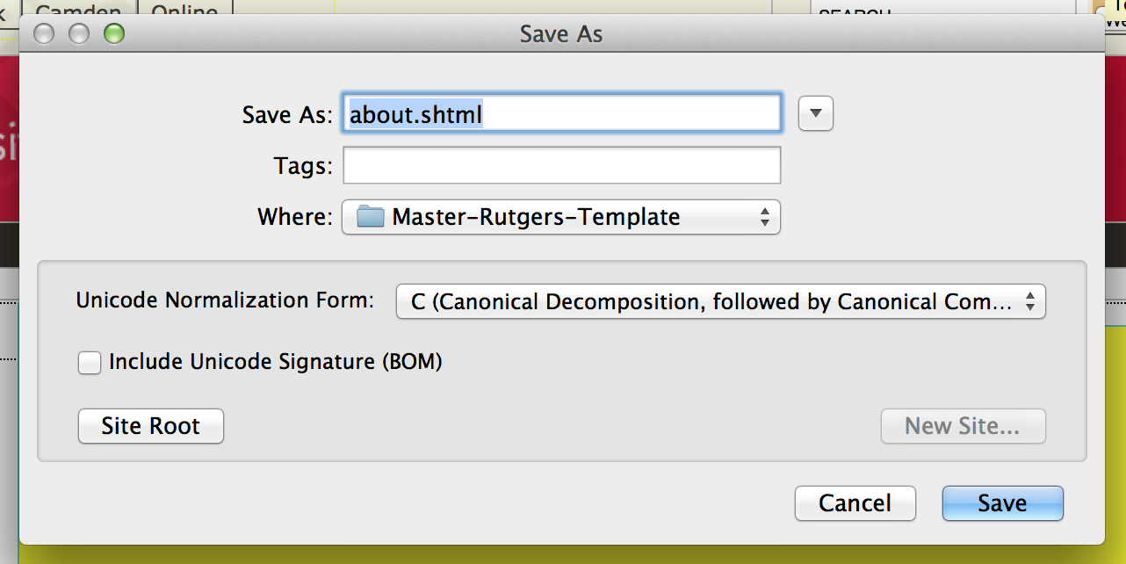

## Working With Navigation

There are three areas where the navigation of the website is displayed:

1. On the homepage, in the lower center area (site map)
2. In the black horizontal bar at the top of the site (top level pages)
3. In the left sidebar area on individual pages (lower level pages)

### Update the Homepage Navigation

See Site Map for instructions on how work with this area of the homepage.

### Update the Top Level Navigation

The top navigation bar is currently being auto generated using JavaScript. The respective tabs will also be set active using the JavaScript. Please note that the navigation will not show up in the Macintosh HD:Users:huacyang:Desktop:Screen Shot 2013-12-23 at 2.16.17 PM.png, it will only display on the Macintosh HD:Users:huacyang:Desktop:Screen Shot 2013-12-23 at 2.43.35 PM.png view or on the web browser. To update the fields, please do the following:

1. On the top of the Dreamweaver program, click on “File” and select “Open…”

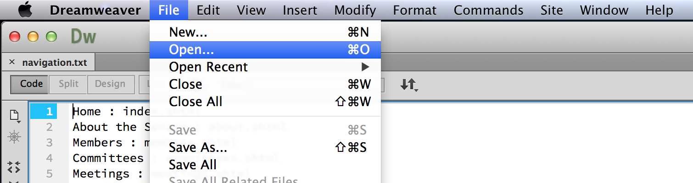

1. On the popup panel, please select the **navigation.txt** file. This text file is located on the root directory.

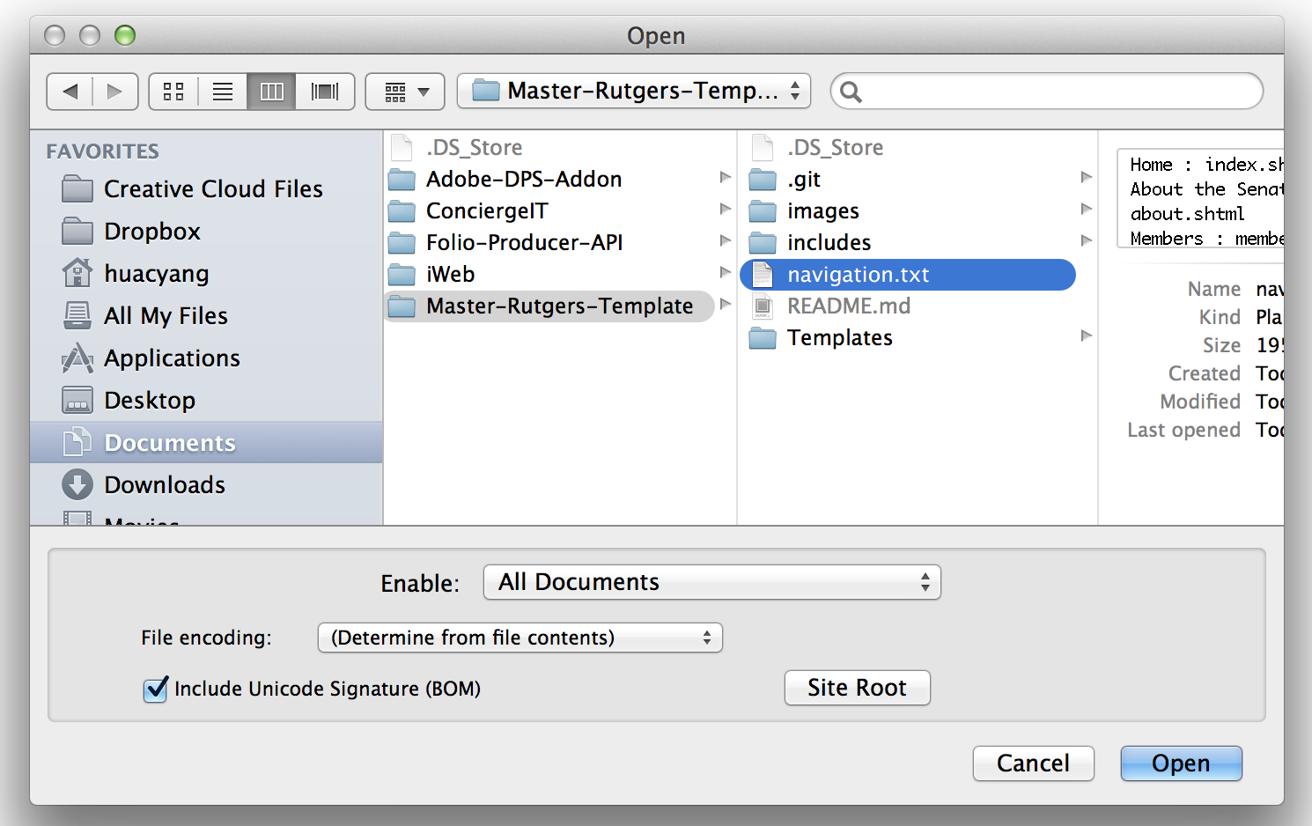

1. In the **navigation.txt** file, please enter navigation tabs in the following format:
   1. [Name of the navigation tab] : [Name of the file to navigate to]
   2. For example, for the Home page tab, you would enter the following: *Home : index.shtml*
   3. Please do not leave blank lines anywhere in this text file.



### Update the Lower Level Navigation

For updating the side navigation bar (on the left of each subpages), please use the Properties panel provided by Dreamweaver.

1. On the top of the Dreamweaver program, click on “Window” and select “Properties”

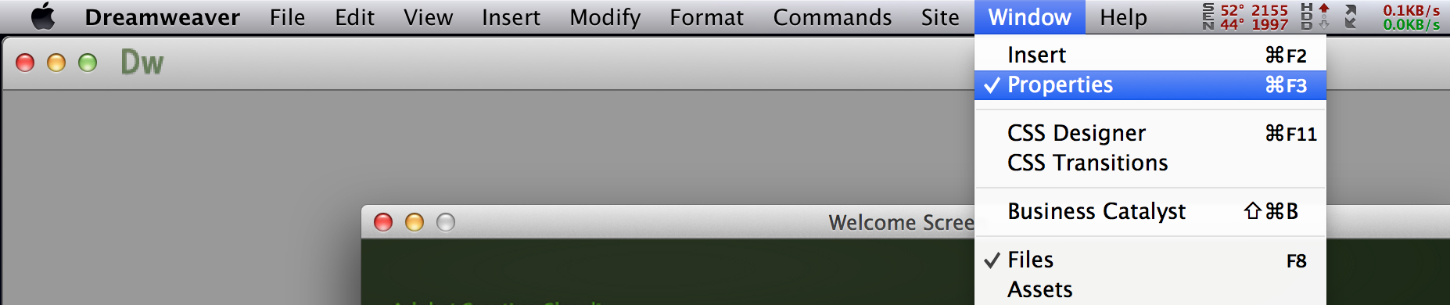

1. The Properties panel is defaulted to open at the bottom of Dreamweaver. In the Macintosh HD:Users:huacyang:Desktop:Screen Shot 2013-12-23 at 2.16.17 PM.png view, simply highly the link to change the name of the link.

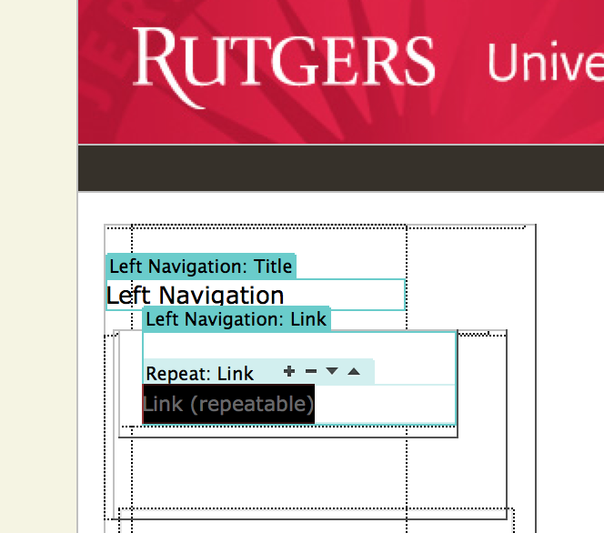

1. To add new links, please **DO NOT** use the enter key, use the “+” icon instead. The icon hovers on top of the first link.

Macintosh HD:Users:huacyang:Desktop:Screen Shot 2013-12-23 at 2.18.57 PM.png

1. To add/update the page reference of each link, select the desired link and navigate to the Properties panel (opened in step 1). In the “Link” field, please enter the page referenced by this link.

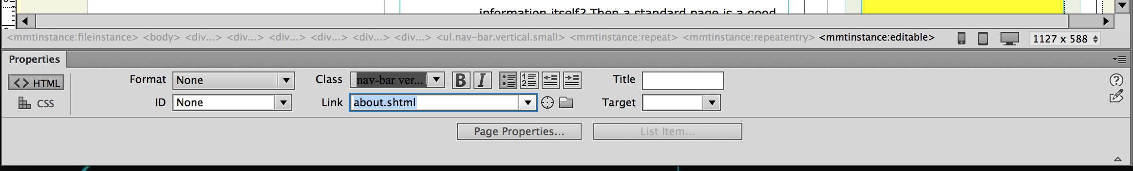

1. The related link section is option. To update, please follow steps 1 – 4.

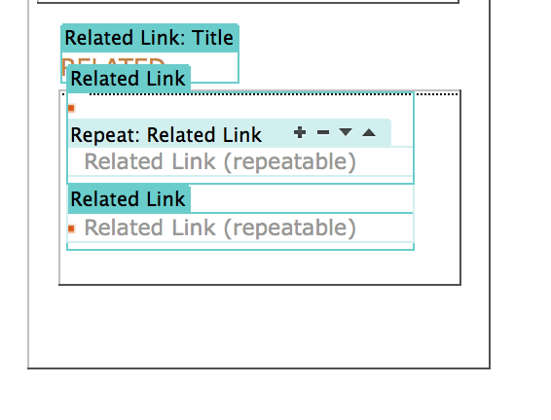

## Using the Live View option in Dreamweaver

When using the Macintosh HD:Users:huacyang:Desktop:Screen Shot 2013-12-23 at 2.43.35 PM.png view option in Dreamweaver, please note that you must remove a line in the **.shtml** file that references a particular CSS file. This is because the Macintosh HD:Users:huacyang:Desktop:Screen Shot 2013-12-23 at 2.16.17 PM.png view option in Dreamweaver is very limited, such that it does not render the page as a regular web browser would. As a result, files that rendered okay on the Live view might not be on the Design view, and vise versa. We have created a CSS file that will override all existing CSS files, just for the Design view.

Therefore, to view the **.shtml** files in the Live view or in the browser, please remove the following (to view in the Design view, please re-add the following):

1. Click on Macintosh HD:Users:huacyang:Desktop:Screen Shot 2013-12-23 at 1.47.55 PM.png, which is on the top left tool panel of Dreamweaver.
2. Please remove the following line (Note: this line will vary depending on which template was used):

* If this was the **hompage**, find and remove the following (should be on line 25):
  + <link type="text/css" rel="stylesheet" href="file:///Macintosh%20HD/Users/huacyang/Documents/GitHub/Master-Rutgers-Template/includes/css/templates/classic_homepage.css" />
* If this was a **subpage with right sidebar**, find and remove the following should be on line 25):
  + <link type="text/css" rel="stylesheet" href="file:///Macintosh%20HD/Users/huacyang/Documents/GitHub/Master-Rutgers-Template/includes/css/templates/standard_subpage.css" />
* If this was a **subpage without right sidebar**, find and remove the following (should be on line 25):
  + <link type="text/css" rel="stylesheet" href="file:///Macintosh%20HD/Users/huacyang/Documents/GitHub/Master-Rutgers-Template/includes/css/templates/standard_subpage_no_sidebar.css" />

## Uploading Your Website

Before pushing the **.shtml** files to the live website, please remove the CSS link, if not already done so. See Using the Live View option in Dreamweaver.